**LEARNING AID USING UNIFIED LEARNING KIT**

**P. SUNITHA(IT) R.K JAISHREE(IT) R.KARTHIKEYAN(IT) C.ILAKIYASREE(IT)**

**Rajalakshmi Institute of Technology, Chennai**

**Rajalaksmi Engineering College, Thandalam**

**ABSTRACT:**

Embedded system has been drastically developed from the last decade which made its application much more important in medical field, radar, industries etc. The goal of our paper is to implement a brain storming game using ULK (unified learning kit) and it poses a challenge to our intellectual thinking. It is a single player reflex type puzzle game.The first module is to display the puzzle on the console window along with the questions in the GLCD screen.The player needs to touch the correct answer from the GLCD screen**.** In the second module the correctness of the answer is made to display in the GLCD display.This procedure happens when the counter is running down from 20 to 0 in the 7_segment display. Finally the score obtained by the player is displayed in 7_segment display

**Key words: Intellectual thinking, single player game, GLCD, CLCD, Seven segment display, ULK (unified learning kit)**

**INTRODUCTION**:

The main objective of our project is to help the people for self evaluating them. “LEARNING AID” not only helps people to judge themselves but also helps to develop their intra personal skills.

**UNIFIED TECHNOLOGY LEARNING PLATFORM:**

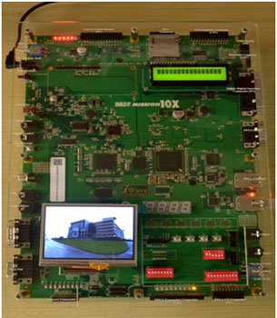

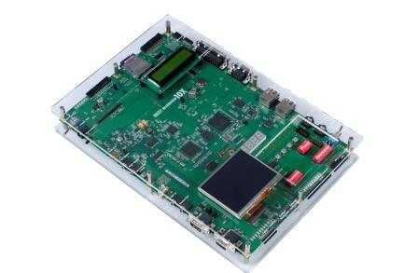

Unified technologies learning platform is an ardent facilitator for aiding engineers gain hand-on, Learn and understand complex and advance technologies simply. Besides, UTLP.

**WORKING PROCEDURE:**

Learning aid is a game come self analysis program wherein a person’s intellectual talent is tested. It is a single player game. Here we have used **CLCD** displayand **GLCD** for giving the input and producing the output. It is a simple game where a picture is displayed on the GLCD and a logical question is asked based on the picture and after selecting the answer from the picture in the next slide the correct answer is displayed Meanwhile a counter starts running down from 20 to 0 .The correct answer is displayed only after the termination of the counter. In the same basis a series of questions are asked for testing the IQ level of the person concerned. At the end, the total score of the person is displayed. This scores helps the viewer to judge the person’s level of thinking The questions asked here are designed in such a way that they act as a aid in the field of medicine. When this project is produced as a product this can be used by the doctors who are handling special kids like autistic kids, dyslexic patients and to judge a person’s perception (that is whether he/she is a pessimistic or optimistic person). This project can also be developed as a hand held device which can be used in hospitals. By using the hand held device the doctors can channelize the treatment for their patients depending upon their answers for the questions. This can also be used for treating cock tail party problem. By using the learning aid one can also improve the concentration level of a person.

**“the cock tail party effect is the phenomenon of brain’s ability to focus one’s auditory attention (an effective of selective attention in the brain )”.**





**FUTURE ENHANCEMENT:**

As a product, it can be used by the Doctors to channelize their treatment for dyslexic patients. It can be used judging a person’s perception. Care taker of the special kids can use this to test the IQ level. This product can be used by parents to check the capability of their kids. This can be re modified depending upon the user’s need.

**CONCLUSION:**

When this project is developed as product this can be used for dual purpose. It can either be used for Gaming or for intellectual tests. This product can be easily marketed by interfacing Arduino and GLCD. Thus becomes user friendly.